In Memory of
Gunner THOMAS WILLIAM COWANS

M M

113351, 84th Heavy Artillery Group, Royal Garrison Artillery
who died age 33
on 19 September 1917
Husband of Annie Cowans, of The Sun Inn, Bedlington, Northumberland.
Remembered with honour
SPOILBANK CEMETERY
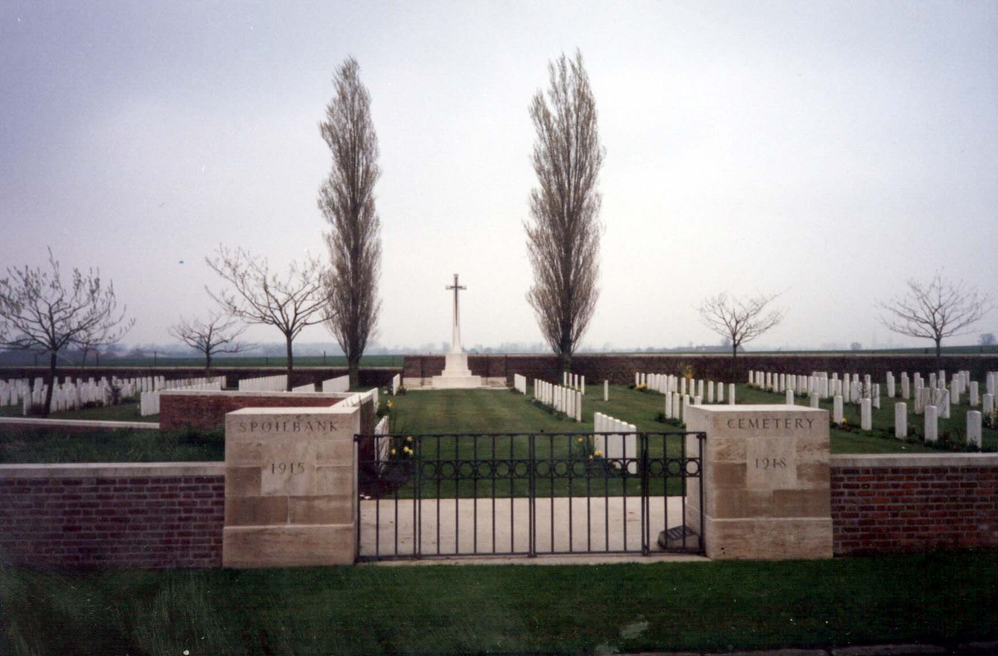
Commemorated in perpetuity by
the Commonwealth War Graves Commission

